

MANAV RACHNA INTERNATIONAL SCHOOL NOIDA

COMPUTER SCIENCE PROJECT

WILO
(A Taxi Booking App)

Student Names: Vinayak Verma & Gahan Lal
Grade: XI-Einstein
Roll No: 14 & 5
Session: 2018-2019

Certificate
This is to certify that Vinayak Verma and Gahan Lal studying in grade XI have successfully completed the computer science project for the year 2018-2019.

Ms. Sakshi Gandotra Ms. Nindiya Saket
Faculty Principal

Acknowledgement

We would like to express our special thanks of gratitude to our teacher Ms. Sakshi Gandotra as well as our principal Ms. Nindiya Saket who gave us the golden opportunity to do this wonderful project on trying to develop an app like UBER.

Index

Serial No. | Topic | Page No.
1. | Certificate | 2
2. | Acknowledgement | 3
3. | Introduction | 5
4. | System Requirements | 6
5. | Salient Features | 7
6. | Code | 8
7. | Output | 30
8. | Scope of Improvement | 38
9. | Bibliography | 39

Introduction

To develop a taxi booking app like UBER using Python language.

Our topic was taxi booking. We researched about some taxi booking apps (UBER). We concluded that UBER would be a good choice.

Our taxi booking app Wilo has features like:
- Opening an account
- Login/Signup
- Booking a taxi
- Calculating fare
- Canceling ride

System Requirements

Main Processor: Intel Atom® processor / Intel® Core™ i3 processor or later

Hard Disk: 2-3 GB

RAM: 2 GB

Operating System: Windows 7 or later / Linux / macOS

Language: Python

Salient Features

- S.O.S signal to alert nearest police patrol unit about your location
- Choosing mode of payment

- You can choose between 4 types of vehicle like:
  - Auto
  - Sedan
  - SUV
  - Pool (Sedan)

Code

import random
import time
def login():
b=str(input("Do you already have an account. Y/N: "))
if b=='Y' or b=='y':
c=str(input('Email: '))
d=str(input('Password: '))
if c=="gg@gmail.com" and d=="VV":
print("WELCOME BACK ".center(50))
print(cf.center(50))
print(book_ride())
elif c=="gg@gmail.com" and d!="VV":
print("Password Incorrect")
print("Try Again")
print("Or Reset Password")
print(Again_Reset())
elif c!="gg@gmail.com" and d=="VV":
print("Invalid Email")
print(login())
elif c!="gg@gmail.com" and d!="VV":
print("Invalid Email")
print(login())
elif b=='N' or b=='n':
print(singup())
print(book_ride())
else:
print("Invalid input")
print(login())
def finding():
driver=['Ram','Sham',"Ritu",'David','Rajdeep','Rahul','Shubham','Nupur','Sudhir','Majnu']
print("\n")
print('Driver Name: '.center(50),random.choice(driver))
print("\n")
Number_Plate=['DL16BX5440','UP16DF4584','DL14BD4732','DL16BP4521','UP16KL8721']
print('Number Plate: '.center(50),random.choice(Number_Plate))
print("\n")
phone_no=['1228751736'.center(50),'3478459652','4425730175','5674152176','6778924657','7812847520','4513674258','9010256473','8788773366','1111111111']
print('Phone Number: '.center(50),random.choice(phone_no))
print("\n")
stars=['3','5','4','5','3','4','4','3','4.5','4.5']
print('Star Rating: '.center(50),random.choice(stars))
def Again_Reset():
print("1. To Try Again")
print("2. To Reset Password")
ee=str(input("Enter: "))
if ee=='1':
print(login())
elif ee=='2':
f=str(input('Email: '))
if f=="gg@gmail.com":
print("Mail Has Been Sent To Reset Your Password".center(50))
elif f!="gg@gmail.com":
print("Invalid Email")
print(Again_Reset())
else:
print("Invalid Figure")
print(Again_Reset())
def singup():
c=str(input('Email: '))
d=str(input('Password: '))
g=str(input("Reenter Password: "))
if d==g:
print("WELCOME TO WILO".center(50))
print(cf.center(50))
print(df.center(50))
else:
print("Password Doesn't Match")
def payment():
pay=str(input("Enter Your Choice(by number): "))
if pay=='1':
pass
elif pay=='2':
print("1. ICICI Bank")
print("2. SBI Bank")
print("3. IndusInd Bank")
print("4. AXIS Bank")
bank=str(input("Enter The Number Of Your Bank: "))
if bank=='1':
print("Welcome To ICICI Bank")
print("1. Debit Card")
print("2. Credit Card")
card_ty=str(input("Enter"))
if card_ty=="1":
print("Enter Your Debit Card Details:")
card_no=str(input("Enter Card Number: "))
cvv=str(input("Enter CVV Number: "))
print("Enter Expiry Date")
mot=str(input("Month: ".center(25)))
yr=int(input("Year: ".center(25)))
if yr<2019:
if mot=="January" or mot=="JANUARY" or mot=="january":
print("Your Card Has Been Expired")
print("Try Again")
print(payment())
else:
pass
else:
otp=str(input("Enter OTP: "))
print("Your Card Has Been Registered To This Account For This Ride")
elif card_ty=="2":
print("Enter Your Credit Card Details:")
card_no=str(input("Enter Card Number: "))
cvv=str(input("Enter CVV Number: "))
print("Enter Expiry Date")
mot=str(input("Month: ".center(25)))
yr=int(input("Year: ".center(25)))
if yr<2019:
if mot=="January" or mot=="JANUARY" or mot=="january":
print("Your Card Has Been Expired")
print("Try Again")
print(payment())
else:
pass
else:
otp=str(input("Enter OTP: "))
print("Your Card Has Been Registered To This Account For This Ride")
else:
print('Wrong Input')
print(payment())
elif bank=='2':
print("Welcome To SBI Bank".center(50))
print("1. Debit Card")
print("2. Credit Card")
card_ty=str(input("Enter"))
if card_ty=="1":
print("Enter Your Debit Card Details:")
card_no=str(input("Enter Card Number: "))
cvv=str(input("Enter CVV Number: "))
print("Enter Expiry Date")
mot=str(input("Month: ".center(25)))
yr=int(input("Year: ".center(25)))
if yr<2019:
if mot=="January" or mot=="JANUARY" or mot=="january":
print("Your Card Has Been Expired")
print("Try Again")
print(payment())
else:
pass
else:
otp=str(input("Enter OTP: "))
print("Your Card Has Been Registered To This Account For This Ride")
elif card_ty=="2":
print("Enter Your Credit Card Details:")
card_no=str(input("Enter Card Number: "))
cvv=str(input("Enter CVV Number: "))
print("Enter Expiry Date")
mot=str(input("Month: ".center(25)))
yr=int(input("Year: ".center(25)))
if yr<2019:
if mot=="January" or mot=="JANUARY" or mot=="january":
print("Your Card Has Been Expired")
print("Try Again")
print(payment())
else:
pass
else:
otp=str(input("Enter OTP: "))
print("Your Card Has Been Registered To This Account For This Ride")
else:
print('Wrong Input')
print(payment())
elif bank=='3':
print("Welcome To Indusand Bank".center(50))
print("1. Debit Card")
print("2. Credit Card")
card_ty=str(input("Enter"))
if card_ty=="1":
print("Enter Your Debit Card Details:")
card_no=str(input("Enter Card Number: "))
cvv=str(input("Enter CVV Number: "))
print("Enter Expiry Date")
mot=str(input("Month: ".center(25)))
yr=int(input("Year: ".center(25)))
if yr<2019:
if mot=="January" or mot=="JANUARY" or mot=="january":
print("Your Card Has Been Expired")
print("Try Again")
print(payment())
else:
pass
else:
otp=str(input("Enter OTP: "))
print("Your Card Has Been Registered To This Account For This Ride")
elif card_ty=="2":
print("Enter Your Credit Card Details:")
card_no=str(input("Enter Card Number: "))
cvv=str(input("Enter CVV Number: "))
print("Enter Expiry Date")
mot=str(input("Month: ".center(25)))
yr=int(input("Year: ".center(25)))
if yr<2019:
if mot=="January" or mot=="JANUARY" or mot=="january":
print("Your Card Has Been Expired")
print("Try Again")
print(payment())
else:
pass
else:
otp=str(input("Enter OTP: "))
print("Your Card Has Been Registered To This Account For This Ride")
else:
print('Wrong Input')
print(payment())
elif bank=='4':
print("Welcome To AXIS Bank".center(50))
print("1. Debit Card")
print("2. Credit Card")
card_ty=str(input("Enter"))
if card_ty=="1":
print("Enter Your Debit Card Details:")
card_no=str(input("Enter Card Number: "))
cvv=str(input("Enter CVV Number: "))
print("Enter Expiry Date")
mot=str(input("Month: ".center(25)))
yr=int(input("Year: ".center(25)))
if yr<2019:
if mot=="January" or mot=="JANUARY" or mot=="january":
print("Your Card Has Been Expired")
print("Try Again")
print(payment())
else:
pass
else:
otp=str(input("Enter OTP: "))
print("Your Card Has Been Registered To This Account For This Ride")
elif card_ty=="2":
print("Enter Your Credit Card Details:")
card_no=str(input("Enter Card Number: "))
cvv=str(input("Enter CVV Number: "))
print("Enter Expiry Date")
mot=str(input("Month: ".center(25)))
yr=int(input("Year: ".center(25)))
if yr<2019:
if mot=="January" or mot=="JANUARY" or mot=="january":
print("Your Card Has Been Expired")
print("Try Again")
print(payment())
else:
pass
else:
otp=str(input("Enter OTP: "))
print("Your Card Has Been Registered To This Account For This Ride")
else:
print('Wrong Input')
print(payment())
elif pay=='3':
pno=str(input("Enter Phone Number: "))
otpp=str(input("Enter OTP: "))
print("Your PayPal Account Has Been Linked To This Account For This Ride")
def book_ride():
print('1. For Options')
print("\n")
print("2. To Resume")
print("\n")
e=int(input("Enter: "))
if e==1:
print("Options".center(50))
print(cf.center(50))
print(df.center(50))
print("1. To Book A Ride")
print("\n")
print("2. To Refer & Earn")
print("\n")
print("3. For About")
print("\n")
dd=str(input("Enter Your Choice: "))
if dd=='1':
print(book_ride())
elif dd=='2':
print("Share Your Referral CODE:'RFG34K'")
print("\n")
print("Invite Your Friends From:")
print("\n")
print("WhatsApp, Messenger, Hangouts, Contacts")
print("\n")
elif dd=='3':
print("WILO".center(50))
print("\n")
print("v3.5.0".center(50))
elif e=='2':
pass
m=str(input("Pickup Location: "))
mm=str(input("Where To? "))
if m==mm:
print("You Can't Book A Ride For Under 500 Meters Of Distance")
print(book_ride())
else:
pass
print('1. For Options')
print("\n")
print("2. To Resume")
print("\n")
eeee=int(input("Enter: "))
if eeee==1:
print("Options".center(50))
print(cf.center(50))
print(df.center(50))
print("1. To Book A Ride")
print("\n")
print("2. To Refer & Earn")
print("\n")
print("3. For About")
print("\n")
print("4. For Going Back")
print("\n")
dd=str(input("Enter Your Choice: "))
if dd=='1':
print(book_ride())
elif dd=='2':
print("Share Your Referral CODE:'RFG34K'")
print("\n")
print("Invite Your Friends From:")
print("\n")
print("WhatsApp, Messenger, Hangouts, Contacts")
elif dd=='3':
print("WILO".center(50))
print("\n")
print("v3.5.0".center(50))
elif dd=='4':
pass
else:
pass
print("Chose Payment Option: ")
print("1.Cash")
print("2.Card")
print("3.PayPal")
print(payment())

print("\n")
print('1. For Options')
print("\n")
print("2. To Resume")
print("\n")
eeeee=int(input("Enter: "))
if eeeee==1:
print("Options".center(50))
print(cf.center(50))
print(df.center(50))
print("1. To Book A Ride")
print("\n")
print("2. To Refer & Earn")
print("\n")
print("3. For About")
print("\n")
print("4. For Going Back")
print("\n")
dd=str(input("Enter Your Choice: "))
if dd=='1':
print(book_ride())
elif dd=='2':
print("Share Your Referral CODE:'RFG34K'")
print("\n")
print("Invite Your Friends From:")
print("\n")
print("WhatsApp, Messenger, Hangouts, Contacts")
elif dd=='3':
print("WILO".center(50))
print("\n")
print("v3.5.0".center(50))
elif dd=='4':
pass
else:
pass
book_fee=10
costpermil=5
print("1.Auto")
print("\n")
print('2.Sedan')
print("\n")
print('3.SUV')
print("\n")
print("4.Pool('Sedan Only')")
print("\n")
vehicel=str(input("Enter Your Choice: "))
if vehicel=='1':
base=40
fare=base+book_fee
print('Fare =',fare)
elif vehicel=='2':
base=60
fare=base+book_fee
print('Fare =',fare)
elif vehicel=='3':
base=80
fare=base+book_fee
print('Fare =',fare)
elif vehicel=='4':
base=50
fare=(base+book_fee)/3
print('Fare =',fare)
else:
print("Invalid input")
print(book_ride())
confirm=str(input("Press 1 to CONFIRM or 2 to CANCEL: "))
if confirm=='1':
print("\n")
print("Finding your ride")
print("\n")
driver=['Ram','Sham',"Ritu",'David','Rajdeep','Rahul','Shubham','Nupur','Sudhir','Majnu']
print('Driver Name: ',random.choice(driver))
print("\n")
Number_Plate=['DL16BX5440','UP16DF4584','DL14BD4732','DL16BP4521','UP16KL8721']
print('Number Plate: ',random.choice(Number_Plate))
print("\n")
phone_no=['1228751736','3478459652','4425730175','5674152176','6778924657','7812847520','4513674258','9010256473','8788773366','1111111111']
print('Phone Number: ',random.choice(phone_no))
print("\n")
stars=['3','5','4','5','3','4','4','3','4.5','4.5']
print('Star Rateing: ',random.choice(stars))
else:
p=str(input("Are you sure you want to CANCEL your ride. Enter Yes or No: "))
if p=='Yes' or p=='yes'or p=='YES':
print(book_ride())
else:
print("\n")
print("Finding your ride")
driver=['Ram','Sham',"Ritu",'David','Rajdeep','Rahul','Shubham','Nupur','Sudhir','Majnu']
print("\n")
print('Driver Name: ',random.choice(driver))
Number_Plate=['DL16BX5440','UP16DF4584','DL14BD4732','DL16BP4521','UP16KL8721']
print("\n")
print('Number Plate: ',random.choice(Number_Plate))
print("\n")
phone_no=['1228751736','3478459652','4425730175','5674152176','6778924657','7812847520','4513674258','9010256473','8788773366','1111111111']
print('Phone Number: ',random.choice(phone_no))
stars=['3','5','4','5','3','4','4','3','4.5','4.5']
print("\n")
print('Star Rating: ',random.choice(stars))
print("\n")
time.sleep(2)
print("Your Driver Is Here!".center(50))
print("\n")
time.sleep(1.5)
print("1. For S.O.S")
print("\n")
time.sleep(1.5)
print('2. To Ignore S.O.S')
print("\n")
j4=str(input(": "))
if j4=='1':
print("\n")
time.sleep(1)
print("Sending Your location to nearest police patrol unit".center(50))

else:
time.sleep(1.5)
print("You have reached your destination")
time.sleep(1)
print('\n')
g=str(input("Enter Number Of Stars For Your Ride: "))
print('\n')
print("Thank You".center(50))
print('\n')
print("1. To Book Another Ride")
print('\n')
print("2. To Quit")
suree=str(input(": "))
if suree=='1':
print('\n')
print(book_ride())
elif suree=='2':
quit()

print("WELCOME TO WILO".center(50))
cf=input("Enter Your Name: ")
df=input("Enter Your Mobile Number: ")
print(login())

Output

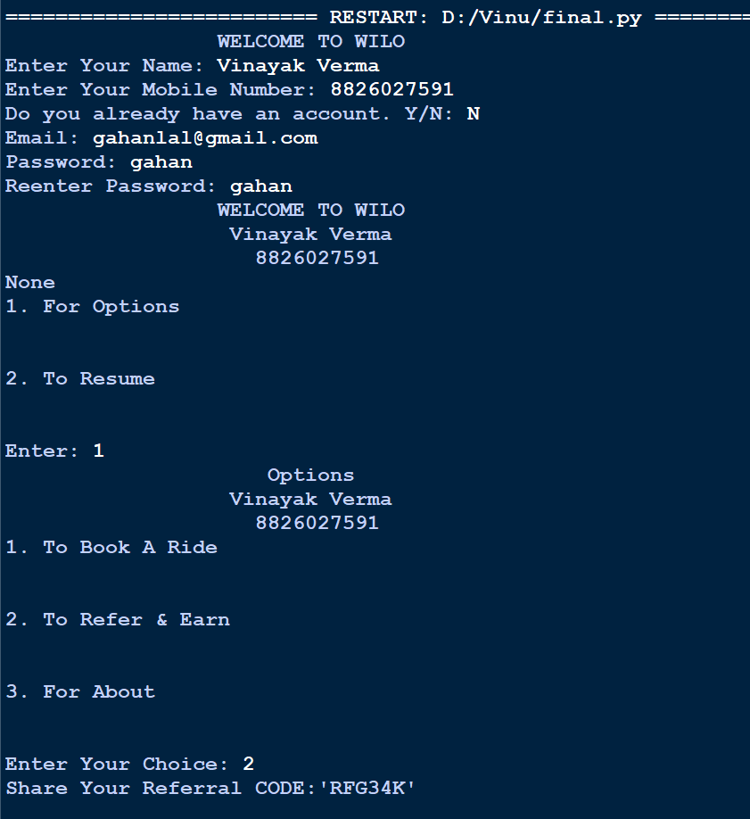

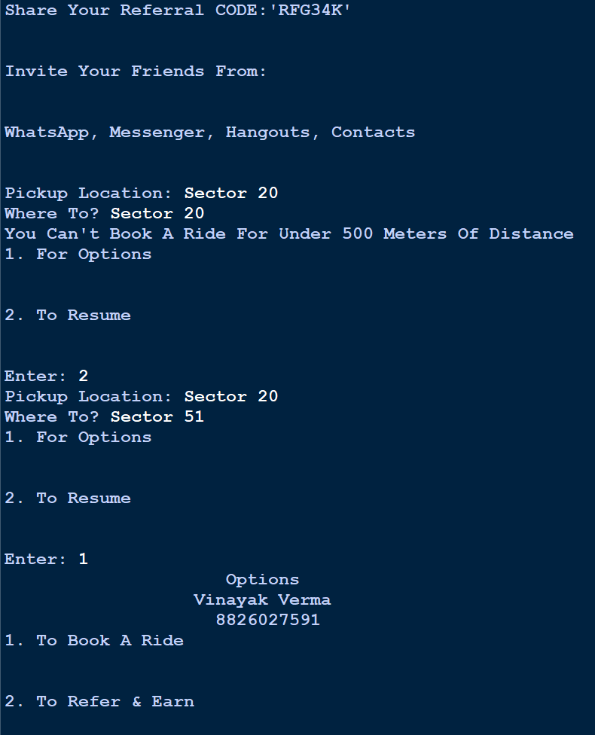

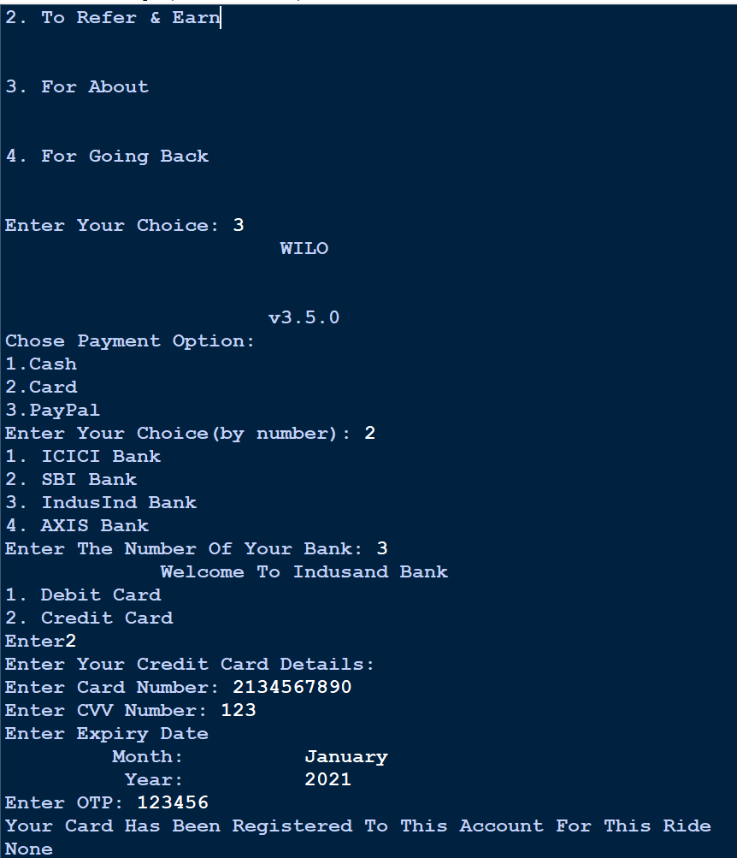

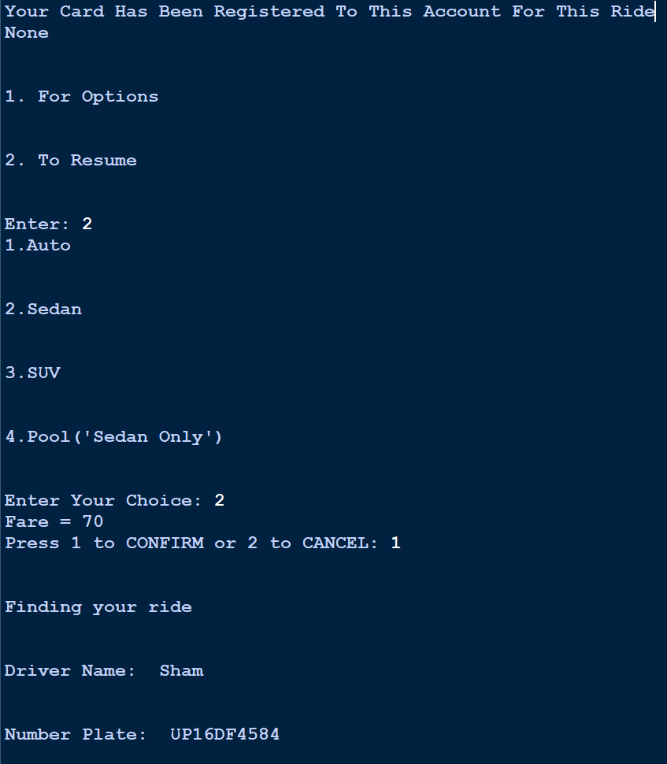

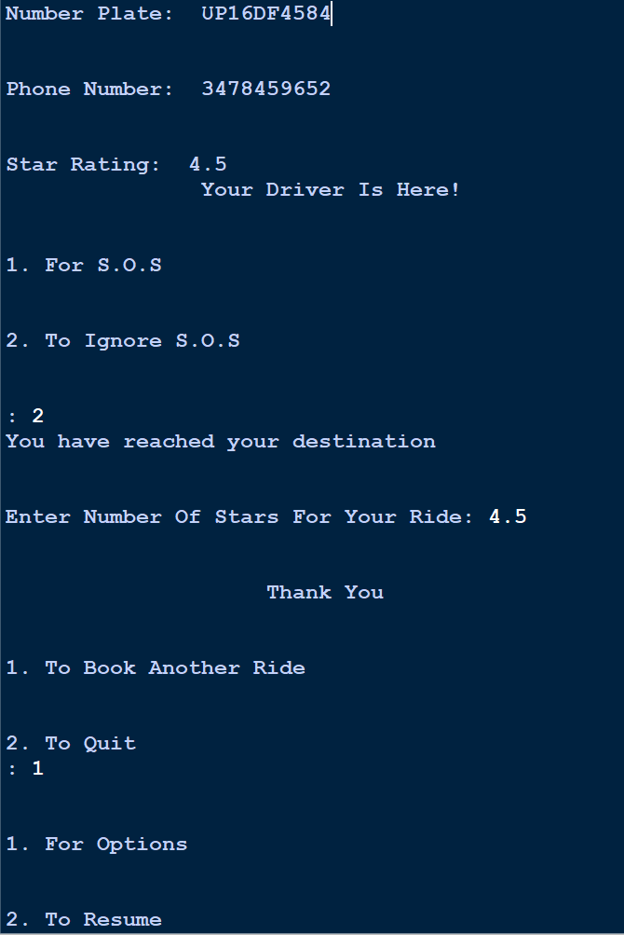

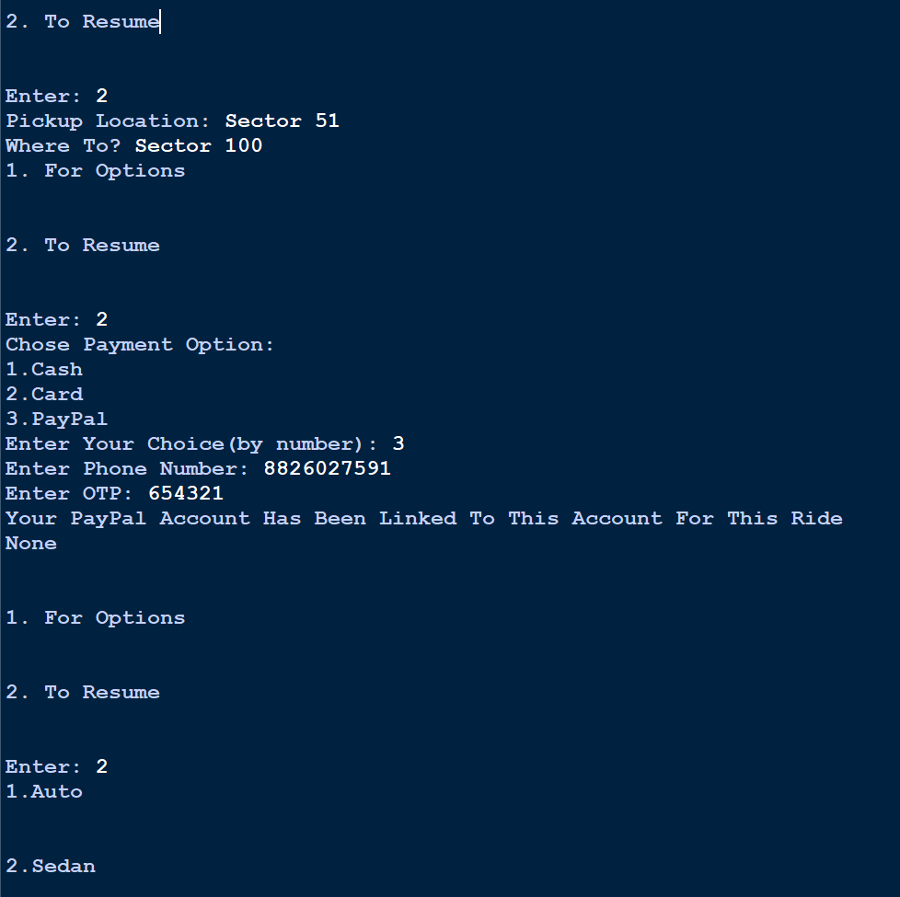

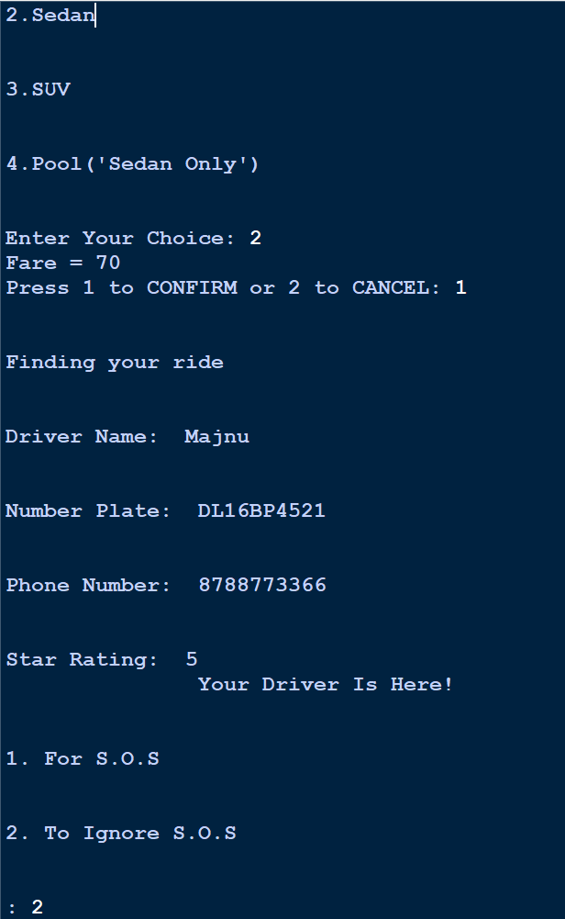

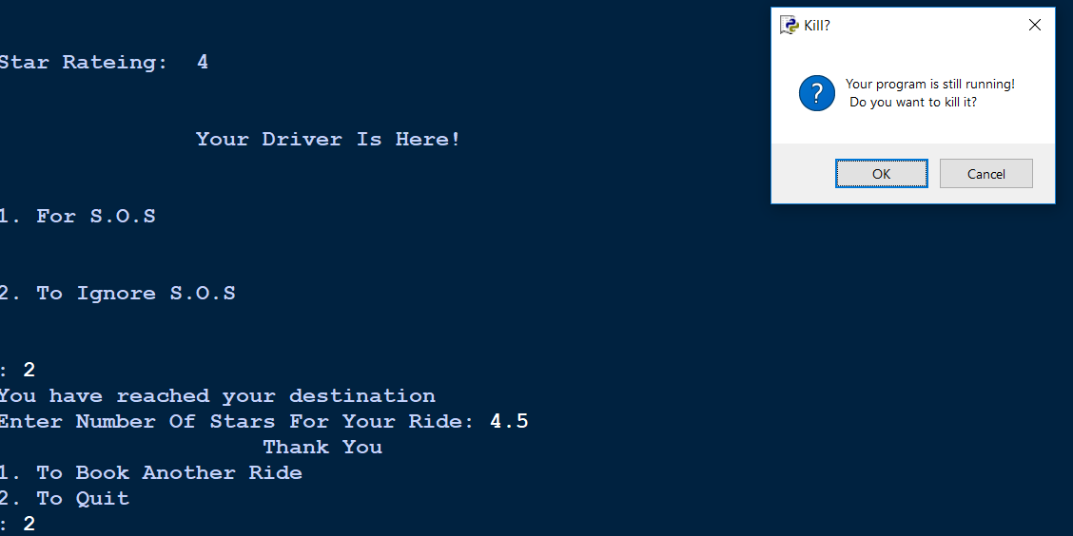

Scope of Improvement

- We can connect google maps to our program to find the distance between the two places and the time taken to reach the destination.
- We can also connect MySQL database to store all the data of all signups we get.
- We can also add picture of the driver
- We can make it more realistic like UBER
- And after we find the distance and time we can use more realistic calculations for the bill
- Using google maps we can also set the minimum and maximum area covered by a particular vehicle type.

Bibliography

- How to use center command?
  - https://www.programiz.com/python-programming/methods/string/center
- Took ideas from UBER

